WEEK 3:
TASK 1:
import java.util.*;
import java.util.stream.*;
class Student {
String name;
int marks;

Student(String name, int marks) {
this.name = name;
this.marks = marks;
}
}
class Task1 {
public static void main(String[] args) {
Scanner sc = new Scanner(System.in);

int n = sc.nextInt();
List<Student> students = new ArrayList<>();

for (int i = 0; i < n; i++) {
String name = sc.next();
int marks = sc.nextInt();
students.add(new Student(name, marks));
}

int k = sc.nextInt();
List<String> result = students.stream()
.sorted(Comparator
.comparingInt((Student s) -> s.marks).reversed()
.thenComparing(s -> s.name))
.limit(k)
.map(s -> s.name)
.collect(Collectors.toList());
System.out.println(String.join(" ", result));
}
}

OUTPUT:
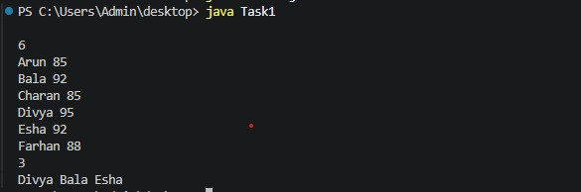

TASK 2:
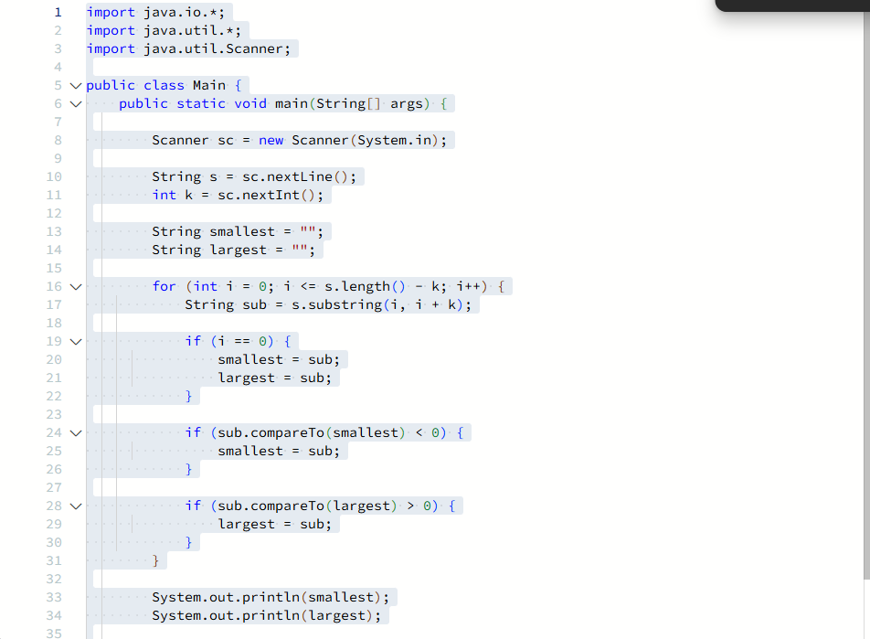

OUTPUT:
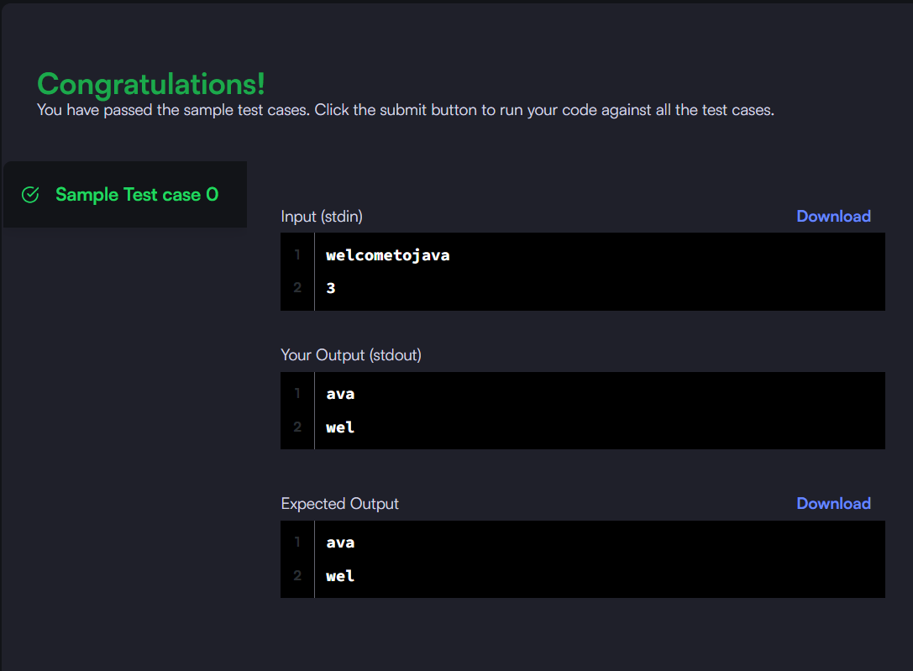

TASK 3:
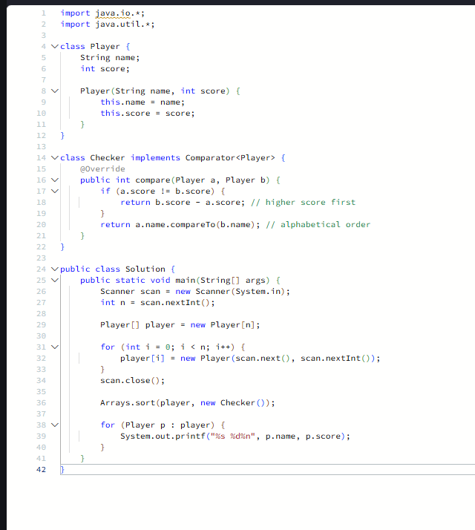

OUTPUT:
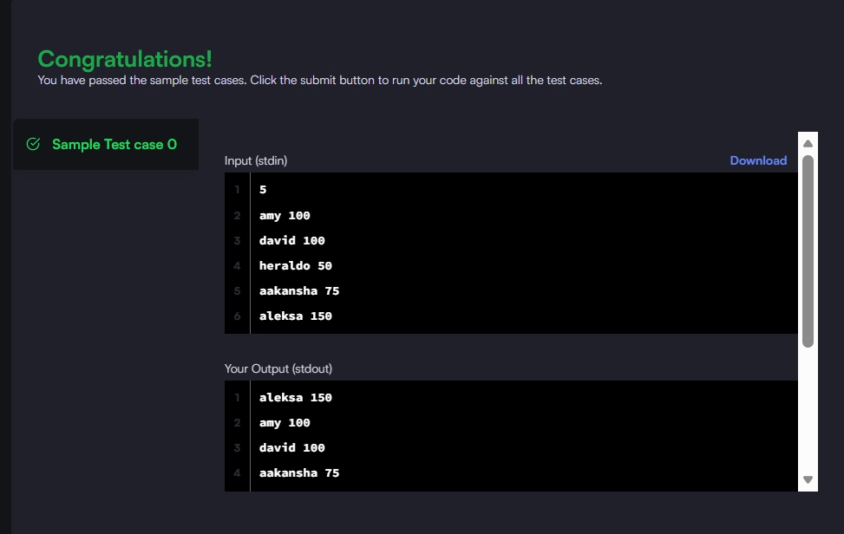

TASK 4:
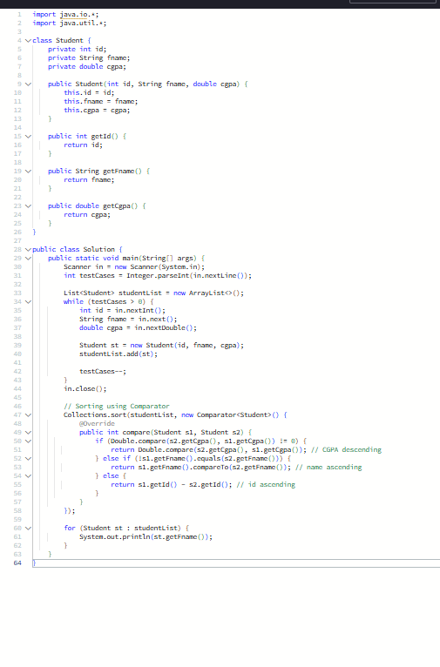
OUTPUT:
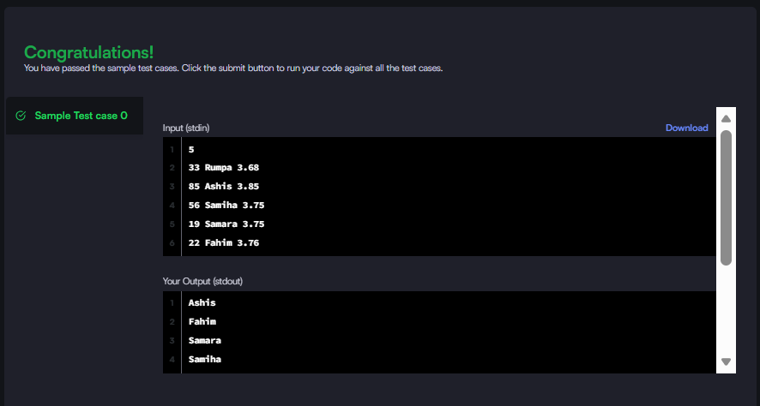

TASK 5:
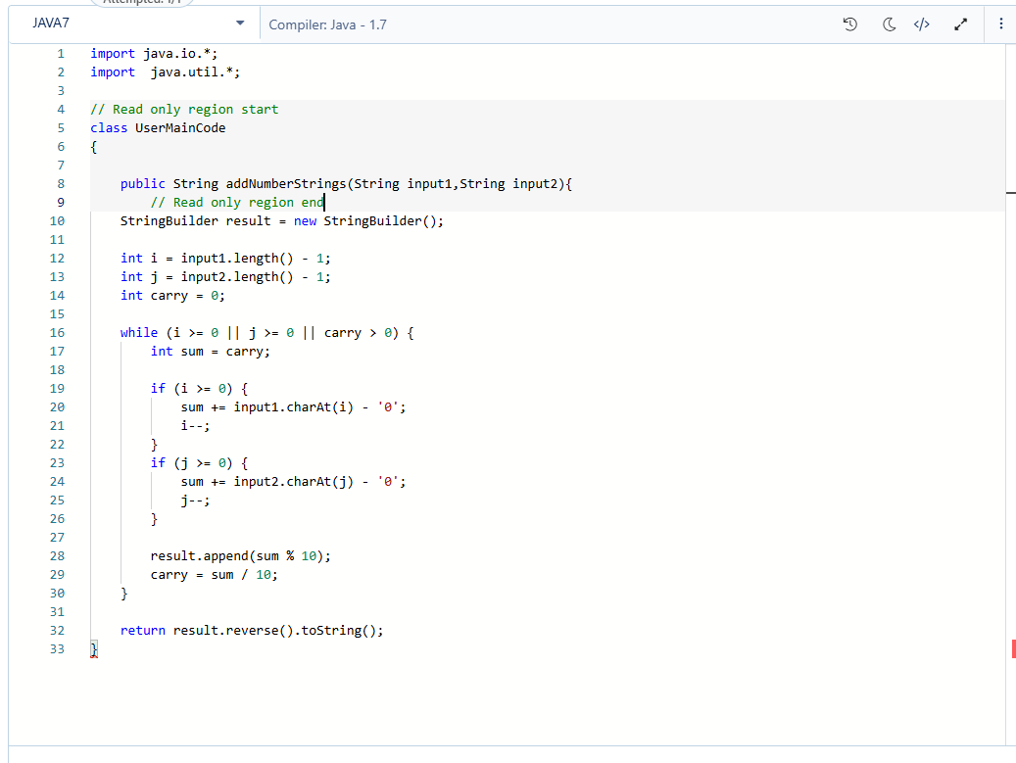

OUTPUT:
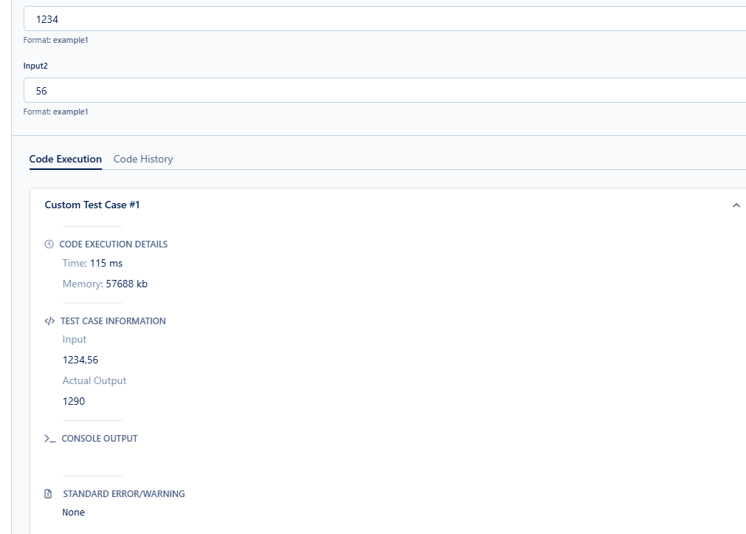

TASK 6:
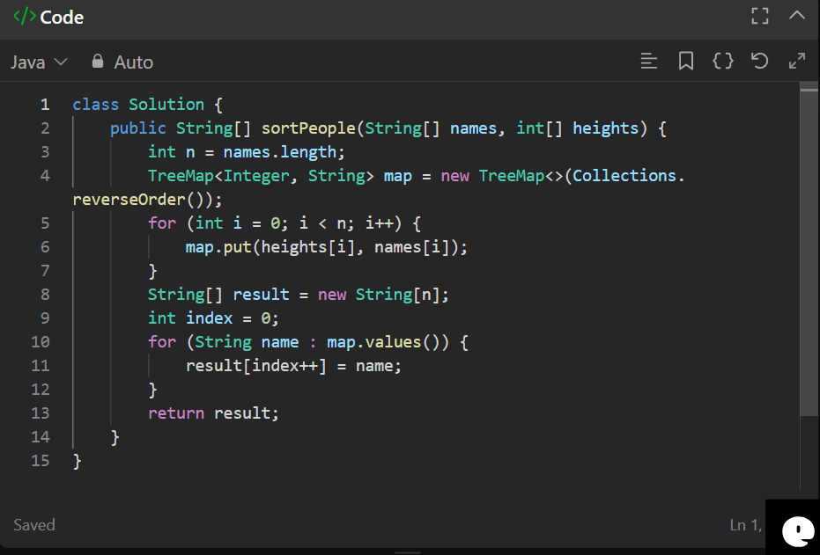

OUTPUT:
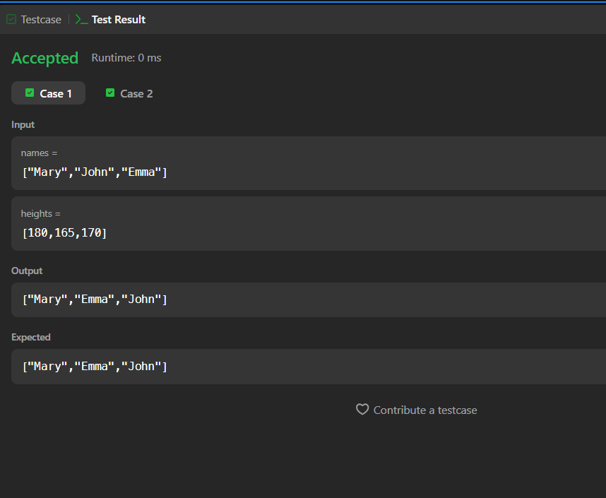

TASK 7:
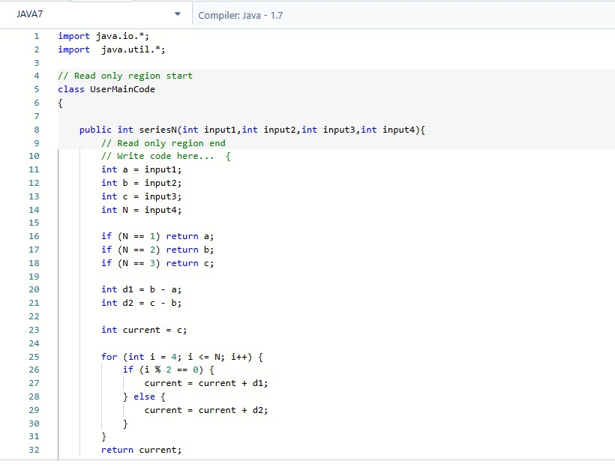

OUTPUT:
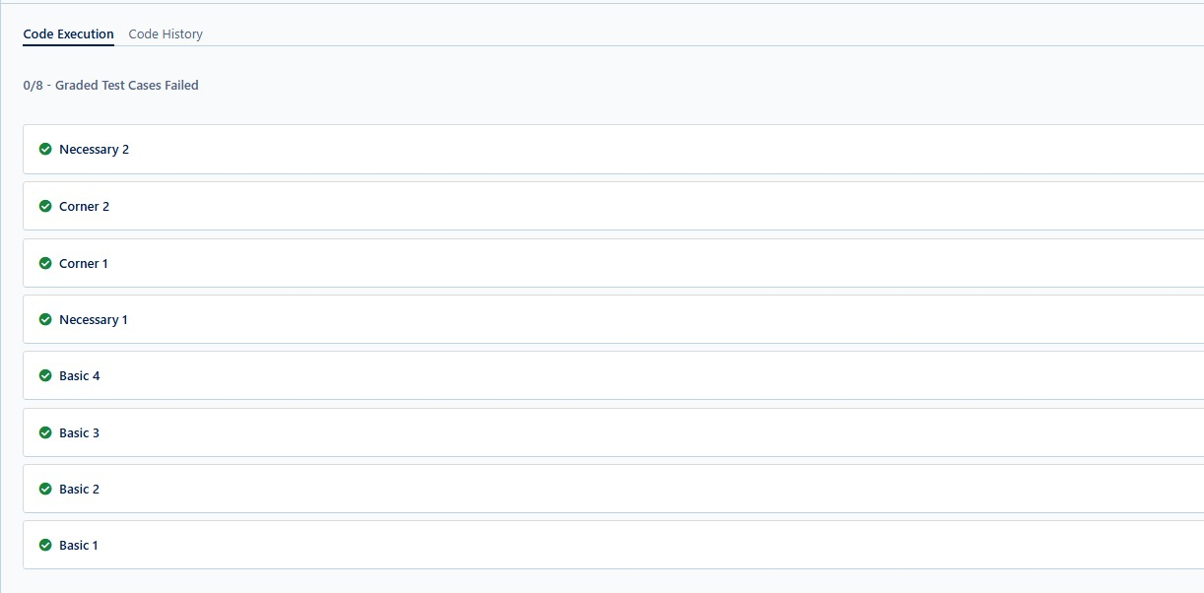

TASK 8:
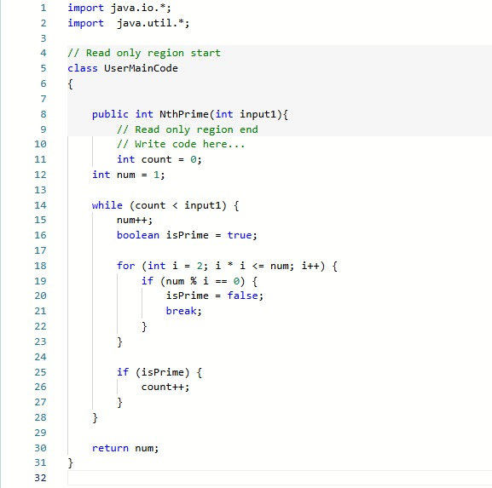

OUTPUT:
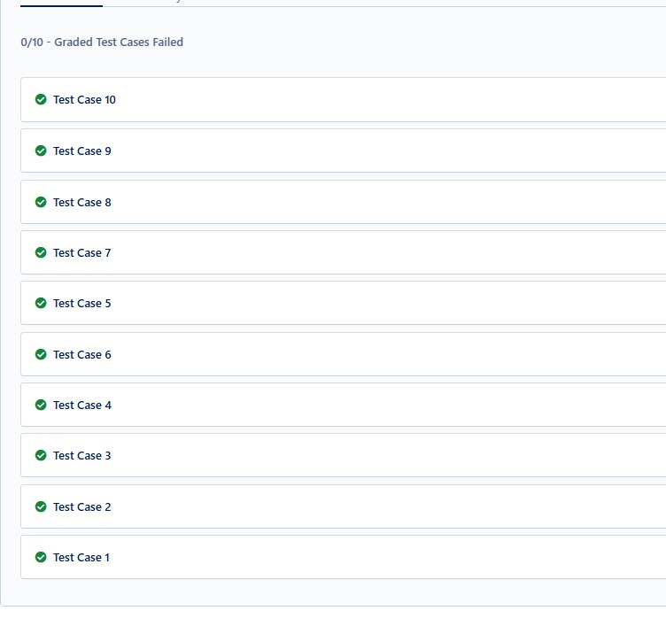

TASK 9:
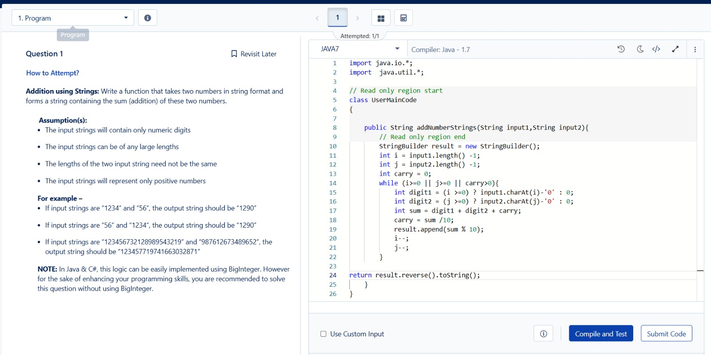
OUTPUT:
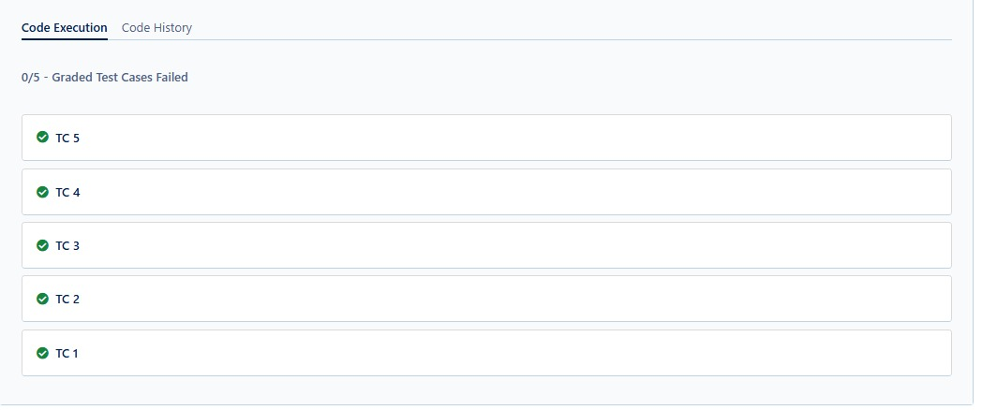

TASK 10:
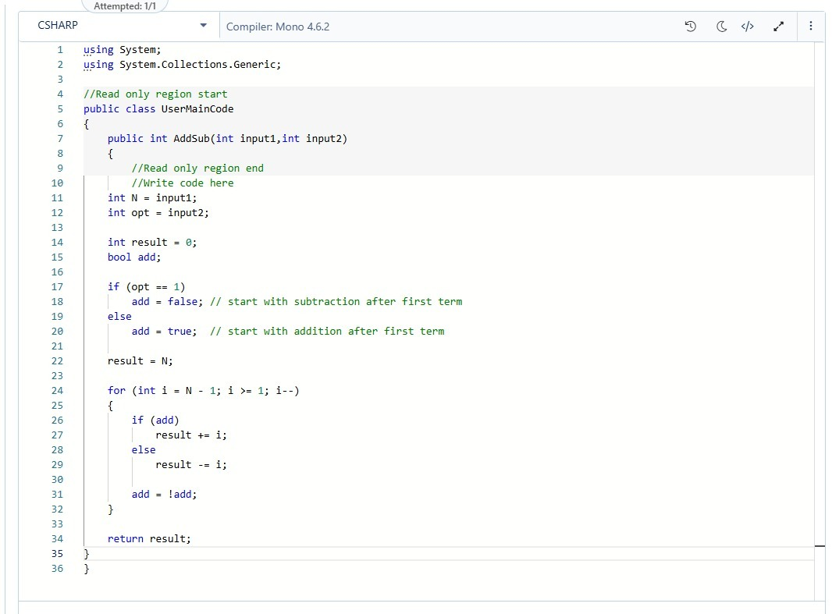

OUTPUT:
